# **Name: Abdurrahman Qureshi**

# **Roll No: 210451**

Practical No: 8

**1)** **Develop a program to demonstrate the use of JTable**

**CODE:**

import javax.swing.*;

import javax.swing.tree.DefaultMutableTreeNode;

import java.awt.*;

import java.sql.Array;

public class Main {

public Main() {

JFrame frame = new JFrame("My System Tree"); frame.setBackground(Color.DARK_GRAY); frame.setForeground(Color.WHITE);

String[] tCols = {"Name","ID","Weapon","Ability"};

String[][] tRows = {{"Battery","3","War Machine","Armour"},{"Prophet","5","Tempest","Glitch"},{"Seraph","4","Annihilator","Combat Focus"},{"Spectre","8","Ripper","Active Camo"},{"Firebreak","11","Purifier","Heatwave"},{"Reaper","7","Scythe","Clone"}};

JTable JT = new JTable(tRows,tCols);

JT.setBackground(Color.DARK_GRAY); JT.setForeground(Color.WHITE);

frame.add(JT);

frame.setSize(400, 300);

frame.setDefaultCloseOperation(JFrame.EXIT_ON_CLOSE);

frame.setVisible(true);}

public static void main(String[] args) {

new Main();}}

**OUTPUT:**

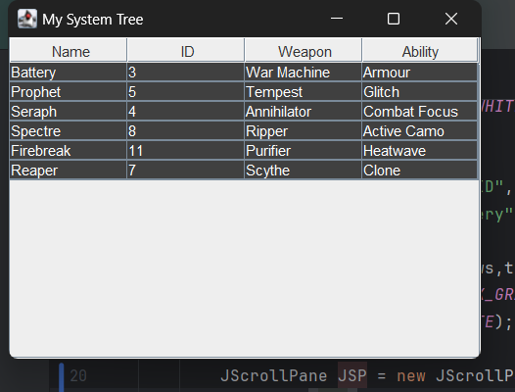

**2) Write a program code to generate the following output**

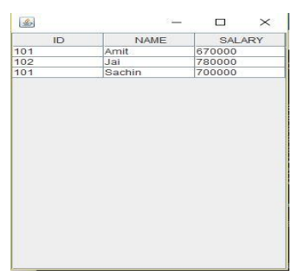

**CODE:**

import javax.swing.*;

import javax.swing.tree.DefaultMutableTreeNode;

import java.awt.*;

import java.sql.Array;

public class Main {

public Main() {

JFrame frame = new JFrame("My System Tree"); frame.setBackground(Color.DARK_GRAY);

frame.setForeground(Color.WHITE);

String[] tCols = {"Name","ID","Salary"};

String[][] tRows = {{"Amit","101","670000"},{"Jai","102","78000"},{"Sachin","101","70000"}};

JTable JT = new JTable(tRows,tCols);

JT.setBackground(Color.DARK_GRAY);

JT.setForeground(Color.WHITE);

JScrollPane JSP = new JScrollPane(JT);

frame.add(JSP);

frame.setSize(400, 300);

frame.setDefaultCloseOperation(JFrame.EXIT_ON_CLOSE);

frame.setVisible(true);}

public static void main(String[] args) {

new Main();}}

**OUTPUT:**

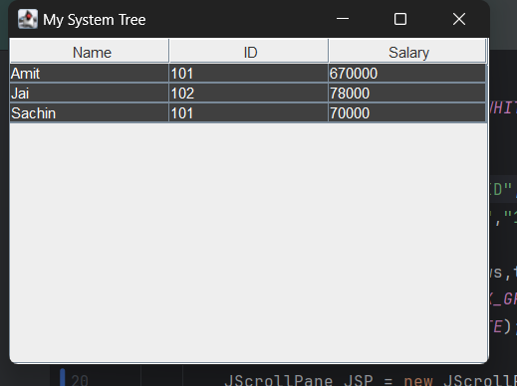

**3)** **Write a Java program to create a table of Name of Student, Percentage and Grade of 10 students using JTable.**

**CODE:**

import javax.swing.*;

import javax.swing.tree.DefaultMutableTreeNode;

import java.awt.*;

import java.sql.Array;

public class Main {

public Main() {

JFrame frame = new JFrame("My JTable"); frame.setBackground(Color.DARK_GRAY);

frame.setForeground(Color.WHITE);

String[] tCols = {"Name","Percentage","Grade"};

String[][] tRows = {{"Battery","72","C"},{"Prophet","85","B"},{"Seraph","94","A"},{"Spectre","88","B"},{"Firebreak","91","A"},{"Zero","74","C"},{"Blackjack","94","A"},{"Sparrow","88","B"},{"Ruin","71","C"},{"Nomad","97","A"}};

JTable JT = new JTable(tRows,tCols);

JT.setBackground(Color.DARK_GRAY);

JT.setForeground(Color.WHITE);

JScrollPane JSP = new JScrollPane(JT);

frame.add(JSP);

frame.setForeground(Color.WHITE);

frame.setBackground(Color.DARK_GRAY);

frame.setSize(400, 300);

frame.setDefaultCloseOperation(JFrame.EXIT_ON_CLOSE);

frame.setVisible(true);

}

public static void main(String[] args) {

new Main();

}

}

**OUTPUT:**

